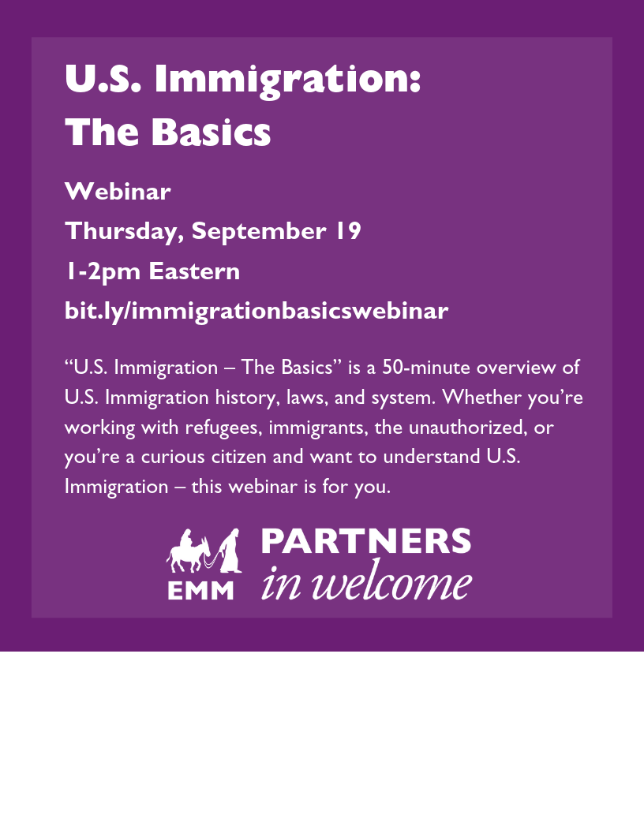

Join us in [room/space] on [date] and [time] to watch U.S. Immigration: The Basics. We will gather to pray, learn, and discuss the webinar. To sign up, please contact [name, email].